8TH EXPERIMENT
1.
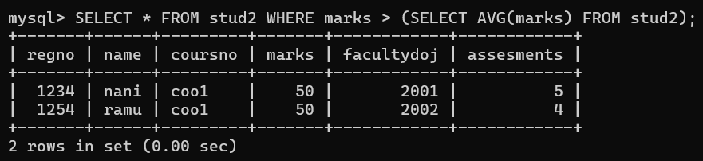

2.
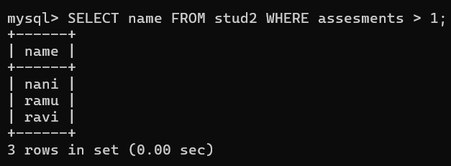

3.
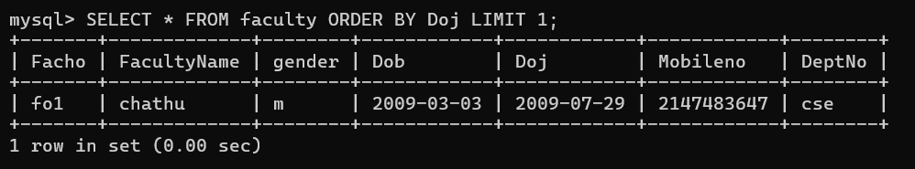

4.
